Interactive game system with computer controlled characters

Second Progress Report

Progress to date

The project is being designed so that it is split into separate units, a game unit, a renderer unit and an AI unit. The game unit is the central part of the project; it will be the only source of input. Information will be passed onto the renderer and AI units from the game unit. This separation is achieved using windows dynamic link libraries (DLL’s).
User Input

Game
Unit
Executable

Renderer Unit
AI Unit
DLL’s

Screen Output

Figure 1: Project units

Currently a basic game unit has been created to allow the user to control its position in the 3D world. Most of the time so far has been spent on implementing the renderer unit and the relevant tools that have been needed to allow the renderer to function.

Tools implemented

3D Studio Max 5.0 ASE to HRZ converter: This is a tool works on a world model created using 3D Studio Max, saved in the ASCII format (.ASE). A lot of information stored is not required and this tool extracts all the relevant information and saves it in a new format .HRZ. This format is constantly being expanded, as more information is required from the original .ASE file (for example light positions, player starting positions, transparent surface information)

Current .HRZ format:
Header
Material List (textures)
Vertex List
Texture Vertex List
Face List (polygons)

BSP creation tool: This tool takes a HRZ file and creates a BSP tree out of the polygons. With this BSP tree the renderer can then draw the polygons in the correct order (back to front) by traversing the binary tree. In the future this tool could be expanded to incorporate a Potential Visibility Set (PVS) were-by each leaf of the BSP tree contains a list of other leaves of the tree that are visible from that node.

The Renderer Unit

This part of the project deals with displaying the output to the user. This unit will draw every pixel that needs to be drawn.

Features implemented:
- Six degrees of freedom (+x, -x, +y, -y, +z, -z)

This allows the user to press keys corresponding to forward, backward, look up, look down, turn left and turn right this way they can navigate around the 3D world.

- Transforming the world using an Nvidia GeForce4 vertex program.

To give the user the impression that he/she is roaming a 3D world, the world needs to be transformed based on the users position. A vertex program provides a fast means of doing this using the 3D graphics card rather than CPU processing.

- Rendering the polygons in the correct order based on the BSP tree.

The BSP tree provides the means to draw the polygons of the 3D world starting from those that are furthest away from the user to those nearest the user (inorder walk). This way the world is rendered correctly. The first version of the BSP tree created, stored each polygon in a node, now all the polygons are stored in the leaves of the tree only, with each leaf contain a set of convex polygons (each polygon faces each other).

- Collision detection (preventing the user walking through walls)

Using the structure of the BSP tree and the fact that each leaf of the tree now contains a set of convex polygons it is very simple to calculate which leaf of the tree the user is in and therefore which polygons need to be checked for collision. [RANTS1]

- Texture mapped polygons.

This is a very simple process due to the functions provided by OpenGL’s API.

- Spotlights using Nvidia GeForce4 Register Combiners.

This gives the user the impression that there is a spotlight shinning on the walls of the 3D world adding to the impression of realism [FRAZR1]

- Text output.

Using OpenGL’s API calls it is possible to copy an image from memory and place it on the screen this way a font can be stored and rendered very easily.

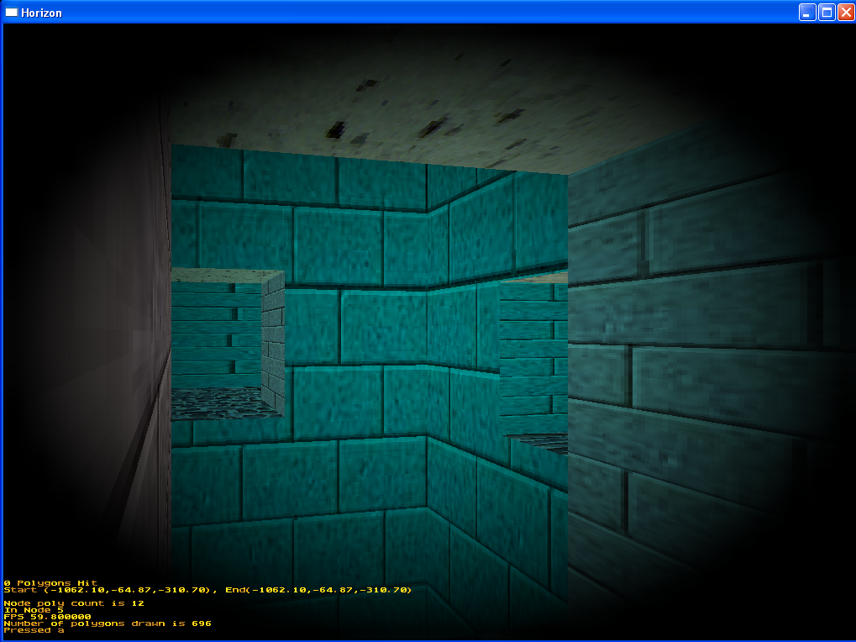
Text Output
Spotlight

Figure 2: Screen shot of a world lit by a spotlight originating from the users position.

The Next Step

As most of the time so far has been spent on getting some form of graphical output so that there is a way to represent the computer controlled characters the next major step is to start designing and implementing the AI unit that will control these characters.

The computer controller characters (CCC) will use very basic rules to begin with; if they ‘see’ the player then they will attack the player. This could be expanded in the future, for example to allow the CCC’s to explore the 3D world and hunt for the user. Possible methods for achieving this are Genetic Algorithms, Neural Networks, etc.

Bibliography

Presentations

[WYNNC1] Wynn, C. OpenGL Vertex Programming, available from http://developer.nvidia.com/docs/IO/1350/ATT/VertexPrograms.ppt [Accessed 27th November 2002]

Chapters in Books

[KAISK1] Kaiser K. (2000) 3D Collision Detection, DeLoura M, editor. Game Programming Gems. 1st Edition. Charles River Media, Inc; 390-402

[RABIS1] Rabin S. (2000) Designing a General Robust AI Engine, DeLoura M, editor. Game Programming Gems. 1st Edition. Charles River Media, Inc; 221-236

Internet Resources

[FRAZR1] Frazier R. (14th August 2000) Per-Pixel Lighting using Register Combiners in OpenGL, available from http://developer.nvidia.com/docs/IO/1235/ATT/PerPixelLighting.zip
[Accessed 27th November 2002]

Theses

[RANTS1] Ranta-Eskola S. (19th January 2001) Binary Space Partioning Trees and Polygon Removal in Real Time 3D Rendering [masters thesis]. Sweden: Computer Science Department of Uppsala University.

